***COVER PAGE***

***Table of Contents***

Table of Contents

1. EXECUTIVE SUMMARY 5

2. SECTION A: CASE STUDY WRITING 7

2.1 PROJECT OVERVIEW 7

2.2 Scope 7

2.3 Time 8

2.4 Quality 8

2.5 Risk 8

2.6 Stakeholders and Communication 9

2.7 Cost 10

2.8 TRIPLE BOTTOM LINE (TBL) 10

2.*8.1 Social* 10

2.*8.2 Economic* 10

2.*8.3 Environmental* 10

3. SECTION B: CASE STUDY ANALYSIS 11

1. **EXECUTIVE SUMMARY**
2. **ABBREVIATIONS & DEFINITIONS**
3. **SECTION A: CASE STUDY WRITING**

3.1 PROJECT OVERVIEW

*3.1.1 Scope*

*3.1.2 Time*

*3.1.3 Quality*

*3.1.4 Risk*

*3.1.5 Stakeholders and Communication*

*3.1.6 Cost*

3.2 TRIPLE BOTTOM LINE

*3.2.1 Social*

*3.2.2 Economic*

*3.2.3 Environmental*

**4. SECTION B: CASE STUDY ANALYSIS**

4.1 CONCEPTUALISATION STAGE

*4.1.1 Scope Management*

*4.1.2 Cost Management*

Early projects of cashflows, operating costs, capital investment required

*4.1.3 Stakeholder and Communication Management*

4.1.4. Quality Management

*4.1.4 Risk Management*

4.2 PLANNING STAGE

*4.2.1 Cost Management*

*4.2.2 Time Management*

*4.2.3 Risk Management*

4.3 EXECUTION STAGE

*4.3.1 Cost Management*

*4.3.1 Time Management*

*4.3.2 Communication / HR Management*

*4.3.3 Quality Management*

4.4 FINALISATION STAGE

*4.4.1 Stakeholder Management*

*4.4.1 Quality Management*

4.5 TRIPLE BOTTOM LINE

*4.5.1 Social*

*4.5.2 Economic*

*4.5.3 Environmental*

**SECTION C: RECOMMENDATIONS TO THE CASE**

5.1 COST MANAGEMENT

5.2 TIME MANAGEMENT

5.3 SCOPE MANAGEMENT

5.4 RISK MANAGEMENT

5.5 STAKEHOLDER MANAGEMENT

5.6 COMMUNICATION MANAGEMENT

5.7 QUALITY MANAGEMENT

**CONCLUSION 26**

**REFERENCES 27**

**APPENDICES**

APPENDIX A: SCOPE OF SERVICES (EXTRACTED FROM THE DESIGN BRIEF AND PROPOSAL).

APPENDIX B: QUOTATION AND DETAILED BREAKDOWN PRICE SCHEDULE (EXTRACTED FROM THE PROPOSAL).

APPENDIX C: ORGANISATIONAL STRUCTURE (EXTRACTED FROM THE PROPOSAL).

APPENDIX D: RISK MANAGEMENT (EXTRACTED FROM THE PROPOSAL).

APPENDIX E: SCOPE VARIATION PROCEDURE (EXTRACTED FROM THE COMPLIED CONTRACT).

APPENDIX F: PROVISIONAL PROJECT SCHEDULE (EXTRACTED FROM THE PROPOSAL).

APPENDIX G: BASELINE GANTT CHART.

APPENDIX H: HAZARD ASSESSMENT (EXTRACTED FROM THE RISK REGISTER).

APPENDIX I: AN EXTRACTED COMPONENT OF THE CONSTRUCTABILITY REVIEW MINUTES.

APPENDIX J: ENGINEERING SUMMARY REPORT TABLE OF CONTENTS.

APPENDIX K: STAKEHOLDER CORRESPONDENCE (EXTRACTED FROM THE ENGINEERING SUMMARY REPORT).

APPENDIX L: CONSTRUCTIVE FEEDBACK FROM GHD AND WC (EXTRACTED FROM THE PROJECT KICK OFF MEETING MINUTES).

APPENDIX M: JOB VARIATION AND PROVISIONAL SUM ACTIVATION.

APPENDIX N: COST ESTIMATE (EXTRACTED FROM THE DESIGN BRIEF).

APPENDIX O: THE KEY PARAMETERS THAT CONTRIBUTED TO COST VARIATIONS (ADAPTED FROM GHD’S APPROVAL TO EXCEED PROJECT BUDGET).

APPENDIX P: THE RISK MANAGEMENT DILEMMA (HARTLEY 2018, P.379).

APPENDIX Q: OUTCOMES FROM BID CLARIFICATION MEETING (EXTRACTED FROM PROPOSAL).

APPENDIX R: STAGE 3 STAKEHOLDER MANAGEMENT ASSUMPTION (EXTRACTED FROM THE ENGINEERING SUMMARY REPORT).

APPENDIX S: UNRESOLVED ITEMS (EXTRACTED FROM THE ENGINEERING SUMMARY REPORT).

APPENDIX T: SEWAGE PUMP QUALITY MANAGEMENT SYSTEM (EXTRACTED FROM THE ENGINEERING SUMMARY REPORT).

APPENDIX U: NOTICE OF WATER CORPORATION AND GHD’S UPCOMING GEOTECHNICAL WORK.

APPENDIX V: PLANNED VALUE, EARNED VALUE AND ACTUAL COSTS (HARTLEY 2018, P.255).

APPENDIX W: POWER AND INTEREST MATRIX.

APPENDIX X: STAKEHOLDER MANAGEMENT MATRIX (HARTLEY 2018, P.160).

APPENDIX Y: RACI OR PARIS MATRICES (HARTLEY 2018, P.161).

APPENDIX Z: COMMUNICATIONS PROCESS MODEL (BELCH & BELCH 2004).

# 1. EXECUTIVE SUMMARY

# 2. SECTION A: CASE STUDY WRITING

## 2.1 PROJECT OVERVIEW

The Kidston Solar Project Phase 1 (KS1), is a large-scale solar farm initiated and managed by Genex Power aimed at contributing significantly to Australia's renewable energy capacity. The purpose of this project was to diversify Genex Power’s portfolio. They initially looked to construct a pumped hydro renewable project however it proved to be harder than estimated. Without a diverse portfolio, if the pumped hydro was not successful, shareholders would not be supportive of future projects. With the push for solar projects by the government and ARENA, Genex saw the opportunity to use the land already secured for the pumped hydro project for KS1 (B. Guo, personal communication, April 5, 2024). By harnessing advanced solar photovoltaic technology equipped with tracking systems, the project aims to optimize solar energy capture, thereby enhancing the stability and reliability of the electricity grid on both local and national scales.

## 2.2 Scope

KS1 had an ambitious scope, estimated to generate around 50MW of electricity annually, sufficient to power approximately 26,500 homes and will help reduce greenhouse gas emissions by around 100,000 tonnes of CO2 each year.

The project tasks encompass work across several key areas. Design and engineering efforts were concentrated on developing detailed plans for the solar farm's layout, structure, and electrical systems to ensure optimal performance and efficiency. The procurement phase was crucial, involving the sourcing and acquisition of all equipment and components essential for the construction and subsequent operational phases of the solar farm. Construction activities were focused on on-site preparation, the installation of solar panels along with their tracking systems, and the setup of critical infrastructure required for the farm’s operation.

The project’s primary components feature the installation of approximately 1.5 million solar panels, along with the establishment of electrical infrastructure—including inverters, transformers, and substations.

Following construction, a rigorous commissioning process was carried out to perform extensive testing and validation of all components, ensuring their correct function and compliance with all relevant safety and regulatory standards. To maintain the solar farm's performance and reliability, operation and maintenance protocols will be implemented, including regular inspections, cleaning, and necessary repairs.

## 2.3 Time

To complete a project in a timely manner acceptable to stakeholders, it is important that a comprehensive schedule management plan is implemented in the planning stage of the project. This is achieved through defining the activities and their sequencing, estimating activity durations and creating the baseline and actual plan (Hartley 2018, p.172). Genex carried out and presented this stage through the implementation of a Gantt chart outlining the life of the project (see Apendix #).

In the execution stage of the project, effective time management is required to control delays and unforeseen circumstances such as potential scope changes. These events such as the delay in Project Finance and Commissioning in the KS1 can ultimately lead to changes in the initial deadlines or prolonging the project (B. Guo, personal interview, 5 April, 2024). Genex utilized the prescribed plan from the planning stage while using the time management technique of lead time to handle unforeseen financing delays during execution. Overall, the project was completed and finalised 1 year after the planned date due to the unexpected delays in the commissioning stage (Genex Power, 2018).

## 2.4 Quality

Quality management serves as a cornerstone, ensuring that every facet of the solar infrastructure aligns with or surpasses industry standards and regulatory mandates. The project stakeholders employs multifaceted approaches to optimise solar power generation, transmission, and storage over its lifespan.

## 2.5 Risk

Risk is an inevitable aspect of any project. Identifying and managing all risks throughout every stage of the project lifecycle is of paramount importance because it provides opportunities to mitigate them.

The initial risk assessment encompassed the environmental and social considerations of the project, including potential objections from local landowners and biodiversity concerns. Due to the project's location on an abandoned mine site, such issues were minimal (B. Guo, personal interview, 5 April 2024).

Genex sourced essential equipment from international suppliers like First Solar (US), SMA (Germany), and NEXTracker (US). However, international procurement introduced additional considerations for project financing, chiefly due to foreign exchange financial risk.

**"This was the first wave of large-scale projects, so, no one’s really had a lot of experience with solar at that point.”** (B. Guo, personal interview, 5 April 2024). Inexperienced teams meant the whole project was prone to making errors, creating high-risk due to the uncertainty surrounding costs and the lack of historical data on similar projects.

Moreover, grid connection providers are often government entities (Ergon Energy in this case, a QLD government owned corporation) and as such, issues of price and time of connection are often non-negotiable, and connecting to the grid emerged as the longest and riskiest part of the project (B. Guo, personal interview, 5 April 2024).

## 2.6 Stakeholders and Communication

*Some of the major stakeholders that highly influenced the project and its requirements are the project partners which include:*

* ***Australia Renewable Energy Agency (ARENA)****: Project sponsor*
* ***Queensland State Government****: Offtake Partner*

*Kidston Solar will be a major contributor to the Queensland Energy Market and as such the state government has interest to support and see its successful implementation. In line with this, the QLD government signed a 20-year support deed with Genex which guarantees a price of $88/kW.*

* Société Générale (an international commercial investment bank) and Clean Energy Finance Corporation (a specialised Australian bank established to promote the growth of renewables in Australia): Both firms supplied majority of the debt funding for the project.
* UGL: EPC (Engineering, Procurement and Construction) as well as Operations and Maintenance contractor.
* AECOM: Owner’s Engineer and Technical Advisor
* Coronium Pty Limited: Specialist Solar PV Consultant
* Ergon Energy: Distribution Connection
* Genex Australia Shareholders

<https://cdn-api.markitdigital.com/apiman-gateway/ASX/asx-research/1.0/file/2995-01777129-2A971460>

Other external stakeholders also had to be considered. The project site is remote and so there was no need to consider the disturbance of local communities or residences, however, liaising was necessary with the indigenous Ewamian people who held native title over the land. The Australian public including those employed by Genex for construction and operations, but also those residing in Queensland/Australia as a whole can be considered stakeholders for this project as any funding Genex received from ARENA comes from the tax-payer, and it will be the Australian public who will be using the power service provided by KS1. By extension, future generations of Australians are indirect stakeholders that must be considered also, and managerial choices must reflect the commitment to the sustainable practices that Genex advertises and publicly supports.

*Please note: This section is not an exhaustive description and only defines the most relevant stakeholders for discussion.*

## 2.7 Cost

The establishment of a cost management plan also remains a crucial aspect in providing a clear framework regarding all “cost estimation, budgeting and cost-controlling processes” that are necessary for the stakeholder's expectations to align (Hartley 2018, p. 208).

The project cost totalled $130.65 million AUS by finalisation in 2017, roughly $40 million above the early initial theorised cost, but only $3.5 million over the later revised budget of $126 million.

<https://arena.gov.au/projects/kidston-solar-farm/>

Roughly 6.77% of this was provided by ARENA in the form of a $8.85 million grant, 13.23% was sourced via equity through issuing of new shares by Genex, and the remaining 80% of the project funding was taken on as debt financing supplied by Societe General and Clean Energy Finance. Though the project’s secure cash inflows guaranteed by the QLD government upon completion could’ve have warranted a higher level of leverage to be taken on, 80% of the total costs was total percentage these banks would offer as they required the company to have some ‘skin in the game’ in terms of equity from its investors.

<https://genexpower.com.au/wp-content/uploads/2021/10/genex_power_knowledge_sharing_-_submission_ii.pdf>

## 2.8 TRIPLE BOTTOM LINE (TBL)

Genex Power was able to implement a sustainable project management approach through their commitment to the TBL. The inclusion of social, economic and environmental opportunities in KS1 highlights their dedication to sustainability.

### 2.8.1 Social

The successful completion of the project demonstrates the support that exists for, and promotes the financial viability of, renewable energy projects in Australia to other industry leaders. This contributes to the shift of the Australian energy sector towards renewables. The project also provided much needed jobs in the area. As an equal opportunity employer, job creation in local communities is a core focus at Genex Power. During the construction phase, 170 jobs were created with 35% of workers female and 15% indigenous (Genex Power, 2021).

### 2.8.2 Economic

KS1 utilises an existing 132kV transmission line connected to the National Electricity Market (NEM), enabling power generation for up to 26,000 households (Genex Power, n.d.). This increase in power generation will stabilise the electricity network in Northern Queensland by reducing the need to import excess electricity from neighbouring areas (ARENA, n.d.).

The location of the KS1 project provided a much-needed economic boost to a depressed region in North Queensland (Genex Power, 2021). As of November 30th, 2021 (ARENA, n.d.), it generated $13.3 million in net revenue across the 2021 financial year (Genex Power, 2021).

### 2.8.3 Environmental

KS1 directly increased the total renewable energy generation in Queensland by 6% (ARENA, n.d.) whilst offsetting 120,000 tonnes of carbon dioxide emissions per annum (Bloch, 2017). In addition, there are minimal environmental issues as the solar farm is built on the abandoned Kidston gold mine meaning the land was already disturbed an therefore primed for reuse. Furthermore, there is ample water supply from the Kidston Dam which was used for construction and operation of the solar farm (Genex Power, 2015).

# 3. SECTION B: CASE STUDY ANALYSIS

## 3.1 Introduction to Project Management Lifecycle

The project management lifecycle of a project can be divided into four stages vital for the completion of a project. These stages include:

1. **Conceptualisation Stage** - The initial stage of the project where the concept is generated. This involves discussing initial objectives, expected outcomes, and alignment with the overall strategic vision. Challenges and advantages are identified, and an assessment is made regarding their potential impact using TBL and life cycle analysis. (Faiello, 2024)
2. **Planning Stage** – Tasks are planned and scheduled. Objectives are solidified, resources are allocated, and quality standards, including those related to TBL and life cycle considerations, are confirmed. Final costs are authorized, timelines are agreed upon, and all other administrative details are resolved. (Faiello, 2024)
3. **Execution Stage** – Project has commenced and emphasis is on tracking actual progress using the schedules developed in Planning Stage as the comparison point of reference. All work (including TBL & Life Cycle thinking) is monitored, controlled & corrected where necessary with schedules being reviewed, revised & updated as required. (Faiello, 2024)
4. **Finalisation Stage** – Project is completed and deliverables are transferred to the client. Utilised resources are either reallocated or appropriately disposed of. The project undergoes evaluation, with reports prepared and presented, and the administrative aspects of the project are concluded. (Faiello, 2024)

## 3.2 CONCEPTUALISATION STAGE

### 3*.2.1 Scope Management*

The conceptualisation stage of KS1 was marked by a rigorous scope management process aimed at establishing a clear project timeline and defining deliverables, namely, an energy production capacity of 50MW annually by Q4 2017. As a part of outlining the boundary of the project, preliminary conceptual drawings of the proposed project site were produced (see Appendix #).

Scope creep was not experienced after this stage in terms of deliverables but only in timeline and cost, as will be discussed.

3.2.2 Stakeholder and Communication Management  
  
Genex had sought approvals such as freehold land acquisition, development approval, and environmental approval in the concept stage. This was done through communication with the Queensland Government Department of Environment and Heritage Protection (DEHP), with all approvals being granted (Genex, 2016). Genex was able to acquire the support from ARENA under their funding agreement, the 20-year revenue guarantee from the QLD state government and an agreement with Ergon Energy for the use of their substation nearby the project site.  
  
Following this, Genex arranged the debt funding agreements with Societe Generale and Clean Energy Finance, as well as appointing AECOM and UGL for the roles of owner’s engineer and preferred EPC & O&M contractor respectively (Technology, 2021).   
  
Figure X shows a stakeholder power interest matrix outlining the key stakeholders.

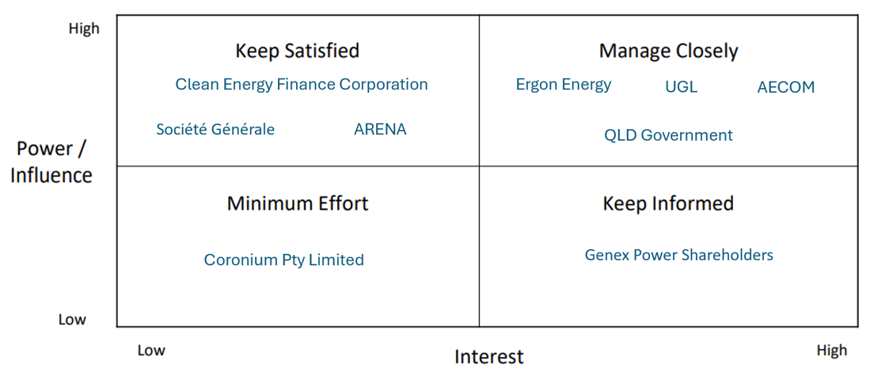

Figure X. Key Stakeholder Power Interest Matrix

3.2.3 Cost Management

The Asia-Pacific Solar Research Conference compiled an analysis report for Genex on KS1, the results of which estimated the typical capital expenditure for a large-scale solar farm to be roughly $90 million (APSRC, 2016). It was also considered that the close proximity of the chosen location of KS1 to an already existing power substation would dramatically lower costs as to build any length of transmission line from a power station to a substation (for the purpose of connecting to the power grid) is very expensive and increases with each kilometre required. This was perhaps the most significant choice related to cost management throughout the entire project. (Ben)

## 3.3 PLANNING STAGE

### 3.3*.1 Risk Management*

Genex paid a margin to UGL to take on all the risks associated with the construction/finalisation of the solar farm, transferring the responsibility for any potential issues or failures, such as equipment malfunctions or construction delays, to UGL (B. Guo, personal interview, 5 April 2024).

PPAs were signed with retailers like Origin Energy and Energy Australia to guarantee revenue for 10 to 20 years to assure revenue certainty in addition to the 20-year revenue support deed already received (B. Guo, personal interview, 5 April 2024). Partnering with established retailers provided the project with access to a wider market for selling its generated electricity while also enhancing market resilience.

### 3.3*.2 Cost Management*

The average price of the seven tenders offers Genex received for the primary contracts for the project was $115,000,000 however negotiated with UGL down to $102,472,000 for them to become the preferred contractor. REFERENCE

Additionally, various hedging methods were used during the financing phase to manage potential costs, however unaccounted for exposure to foreign exchange risk resulted in Genex experiencing heavy foreign exchange costs. This extended the budget by the amount lost and required Genex to return to its shareholders for additional capital raising.

These efforts saw a new revised increased budget of $126 million, an example of a bottom-up / vendor bid analysis approach to budgeting as a firm grasp on the total costs only became apparent after negotiations with contractors were complete. (Ben)

### 3.3.3 Time Management

The result of Genex schedule management planning from feasibility to commissioning is presented in a Gantt chart [see Appendix #]. The chart is effective in illustrating the unique identifiers of the activities, activity durations, imposed dates, the project calendar, and logical relationships in a straightforward way. It can be assumed that lead and lag time are accounted for in the planned durations of each activity.

The time durations for estimated activities were devised through a combination of multiple estimation techniques including expert judgement, group decision-making and parametric estimates (Genex Power, 2016). In addition, the duration for the construction stage was estimated using vendor bid analysis where it is relied upon the market through expression of interest, request for tender and other market invitations to accurately estimated the time for construction presented in the Gantt chart. (Hartley 2018, p.175).

However, the Gantt chart lacks meaningful description of each activity and excludes important information such as resource requirements, underlying assumptions, relevant constraints, and reference requirements.

### *3.3*.4. Quality Management

Genex employed two key tactics to enhance quality management:

Location Selection: The site chosen for KS1 is located roughly 270km northwest of Townsville in Northern Queensland, Australia. (Power Technology, 2021) This location boasts one of the highest solar radiation zones in the country, making it ideal for solar energy generation. (ASX, 2016) Additionally, its proximity to Townsville and Cairns, coupled with access to existing infrastructure like substations and transmission lines, facilitates efficient energy distribution. (Power Technology, 2021) Furthermore, situating the solar farm at the former mine site mitigates environmental impacts, particularly concerning the existing tailings storage facility. (Power Technology, 2021)

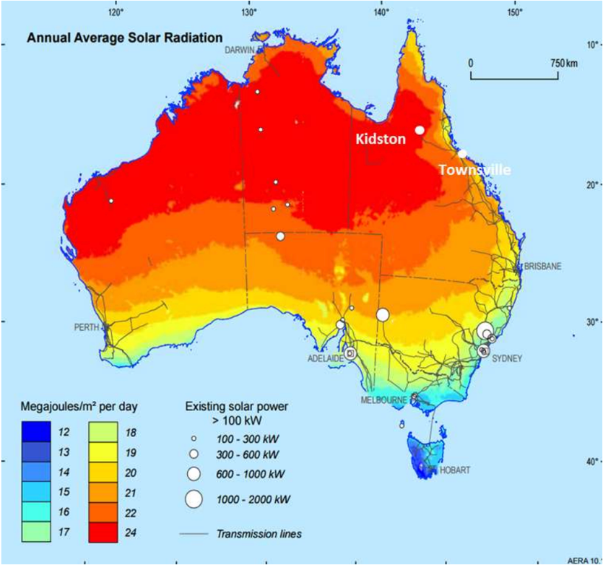

Figure :Project Location - situated in one of the highest solar radiation zones in Australia (ASX)

Collaboration with Experienced Partners: Genex collaborated with seasoned professionals to ensure the project's success. They engaged an experienced owner's engineer, AECOM, to oversee feasibility and evaluate potential contractors. (Power Technology, 2021). The strategic partnership with UGL ensured that the project benefits from the expertise and proficiency of industry leaders, enhancing its overall quality and performance.

## 3.4 EXECUTION STAGE

### 3.4.1 Time Management

Delays in project finance activity (2-3 months after the proposed date) resulted in the original plan needing to be altered. In the original schedule the project finance and construction activities were planned to occur ‘in series’, one following the other in a finish-start relationship (see Appendix #). The company had trouble forecasting the time duration of the financing stating that ‘the specifics involved in securing renewable energy project financing is something which is difficult to foresee, particularly for project developers who had not previously completed project financing in the renewables industry’ (Genex Power, 2017), suggestive of poor activity duration estimation technique. Despite this, Genex was able to start the construction stage before financial closure by taking advantage of lead time (see Appendix #). The ‘in-series’ activities moved to an ‘in-parallel’ format with the overlap representing the lead time as shown in Figure ####.

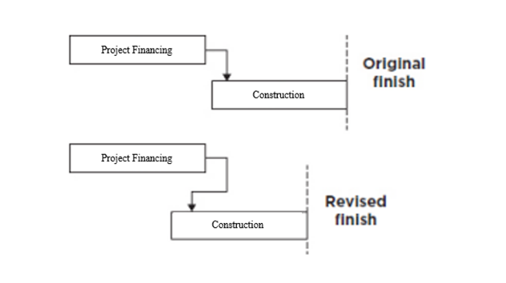

Figure ###:Genex Lead Time/Intentional Acceleration [Adapted From Textbook] (Hartley 2018, p.184)

Figure ### illustrates how the revised project timeline Gantt chart with the lead time Project Financing and Construction was a more accurate timeline for those stages as it was made later.

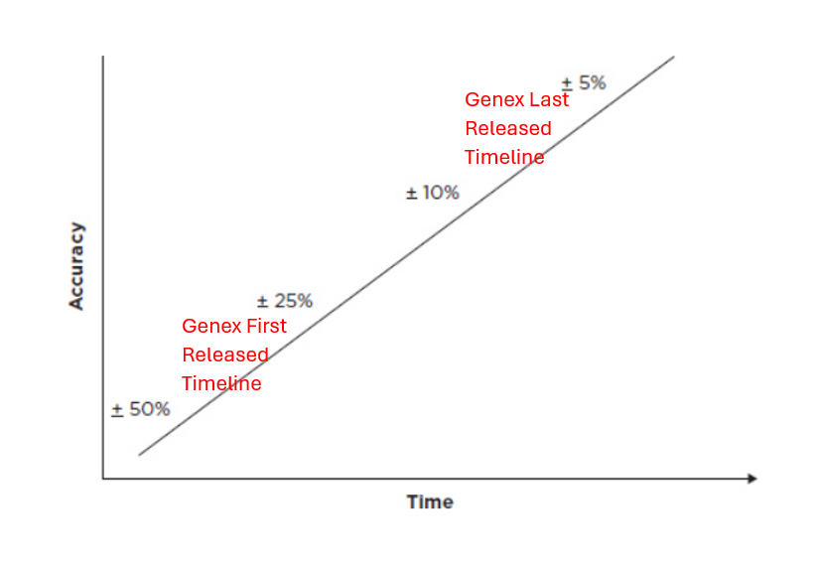

Figure #### Estimating Time Accuracy, Adapted From Textbook (Hartley 2018, p.176)

Although the construction stage was completed on time (Genex Power 2017), unexpected delays in the commissioning stage of the project (connecting to grid) meant that the practical completion date of the project was 1 year later than planned (planned completion – Q4 2017, practical completion Q4 2018) (Genex Power, 2018).

Ben Guo said, “There was a lot of issues doing that right because back then the grid operators were still quite inexperienced in terms of connecting new renewable energy projects... You need additional equipment and whatnot” (personal interview, 5 April, 2024). This demonstrates failure to identify the task dependencies, underestimating the effort required and a lack of understanding of what is required early in the project life cycle which resulted in a delay in the finalisation of the project.

3.4.2 Stakeholders / Communication / HR Management

Communication between stakeholders and HR management was clear and concise in the execution stage, which is evident through the ASX announcements on every step of the ongoing construction. These reports detail the tasks completed since the last announcement with accompanying images, examples of which can be seen in Appendix X (*ASX, 2017).*   
  
Following construction, delays in grid connection caused a dispute between Genex and UGL about how much of the issue was within UGL’s contractual scope and responsibilities. This was settled with a compromise between the two parties after legal negotiations resulting in UGL having to pay Genex upwards of $5 million to partially compensate for delay costs as well as legal court fees (Mr B, Guo personal interview, 5 April 2024). This is an example of a compromising strategy to deal with stakeholder pressures.

### 3*.4.3 Quality Management*

*Quality management tactics implemented by AECOM and UGL include:*

*Compliance with Standards: The EPC Contractor adheres to stringent quality assurance protocols, in line with ISO 9001 management guidelines for construction activities.(Crowley A., 2022) This includes the establishment of a comprehensive Project Quality Assurance system encompassing an overarching Quality Management Plan, Construction Execution Plans (CEPs) for major works components, Inspection and Test Plans (ITPs), and meticulous documentation of testing results and manufacturer data. A dedicated Quality Manager and Team oversee the implementation of these measures, ensuring that quality requirements are consistently met throughout the project's lifecycle. (Amy Crowley, 2022)*

*Utilisation of Innovative Technology: The Kidston solar farm integrates cutting-edge technology, such as First Solar's 4v3 Modules (S4-Modules), renowned for their performance and reliability in various climates worldwide. (Power Technology, 2021) These advanced thin film modules, mounted on a tracking system, optimise sunlight capture by adjusting panel angles to follow the sun's trajectory. (ARENA, 2022) This innovative design enhances the project's capacity factor, ensuring maximum electricity generation efficiency, especially in the hot and humid conditions prevalent at the Kidston site.*

3.5 FINALISATION STAGE

3.5*.1 Stakeholder Management*   
  
*From finalisation onwards, UGL’s responsibilities extend to the management of operations and maintenance of KS1 and has also worked in conjunction with Powerlink to be able to deliver a shared goal of utilising local employment. These opportunities range from waste management and recycling, access works, cleaning services, equipment and machine hiring and many more (Powerlink, 2024).*

*Genex also received registration for KS1 as a Market Generator by the Australian Energy Market Operator (AEMO), and thus, completed all technical and regulatory processes to enable the export of electricity into the NEM.*

*3.5.2 Cost Management*

*Financial projections after execution saw forecasted values which include (all annually): O&M costs of* $1,530,000, $147,000 insurance costs, an assumed inflation of 2.5%, degradation of 0.35%, and a project IRR of 9.295% based on a lifetime of 25 years.

3.6 TRIPLE BOTTOM LINE

*3.6.1 Social*

*The rigorous procedures of identifying and obtaining the most suitable stakeholders, utilising the communication and time management methods have resulted in a project that can be viewed socially as excellent. The completion of the project in a timely manner with a clear and main focus on renewable energy is historical and a pioneer for the industry and socially acceptable amongst the Australian population.*

*3.6.2 Economic*

*Managing cost, time and risk within this project has resulted in a project that has delivered value for its shareholders. Although, there were delays and incidents, proactive management and strong contingency allowed for the project to be one that resulted in a current market capitalisation multiples of what it was before the beginning of the project [asx]*

*3.6.3 Environmental*

*The effective use of scope management and quality management with clear goals (50MW output, decarbonisation energy options) identified in the conceptualisation phase and quality check/quality assurance (QA/QC) throughout the project and afterwords have led to the environmental portion of the TBL of the project being excelled.*

**4. SECTION C: RECOMMENDATIONS TO THE CASE**

**From the unit outline:**

* **Provide effective recommendations for each phase of your project on how to prevent and/or address the problems (and their causes) uncovered in your analysis;**
* **Prioritise recommendations by considering the potential benefits and consequences deriving from them.**
* **There is no right or wrong answer but marks are given for how well you defend and support your arguments with relevant frameworks and theories. Your goal is to provide a convincing argument, supported by relevant conceptual frameworks and theories as to why your recommendations will address the problems and relating causes.**

4.1 TIME MANAGEMENT

*The estimation for the time of the Project Financing provided a big obstacle for the time management of the project. With the Financial close being reached 2-3 months after the proposed time and commissioning finishing 1 year after the planned date, it is recommended that different methods of time estimation should be utilized to avoid necessity for changes in proposed plans. The technique of expert judgement would have been useful, having the input of an expert with specialized input in capital raises to do with renewable energy and knowledge regarding the market would have helped in being able to forecast the amount of time needing to be allocated to financing (Hartley 2018, p.). In addition to this, the utilization of a three-point estimate, (a weighted average requiring the optimistic, pessimistic and most likely estimates that define an approximate range for the expected duration) (Hartley 2018, p.) would have been useful in allocating a greater amount of time to these steps of the project. The three-point estimate would have been especially useful with the existing team Genex had, given they had limited experience in this specialised type of project. Utilising a lower level of confidence would have resulted in more realistic allocation of time duration for Project Financing and Commissioning as illustrated in Figure #### (Hartley 2018, p.).*

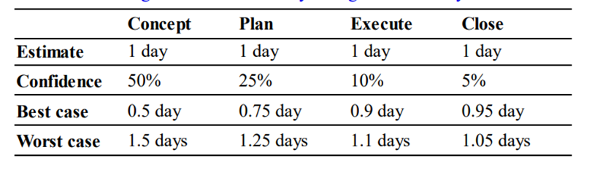

*Figure ### Time estimation and Confidence Illustration (Hartley 2018, p.)*

*Furthermore, a formal recording of these confidence levels being reflected in the presented Gantt chart and a focus on underlying assumptions and impacting constraints would have been useful in forecasting the potential duration of financing (Hartley 2018, p.). A greater understanding of the resource capability in terms of funding and funding would be helpful in providing a more accurate estimation of the activity duration (Hartley 2018, p.). As the project was one of the first of that type in Australia, allocating more time to researching how commissioning would work or seeking international advice could have resulted in a more accurate plan. Another recommendation could be the addition of a Work Breakdown Structure alongside the Gantt Chart, which has the advantage of breaking down each activity which provides information with more meaningful descriptions of what is involved in each activity (Faiello, 2024). This would be useful for stakeholders to understand the specific steps required to be taken in each activity for the estimated duration and may have helped in forecasting the issues that came up in the finalisation stage.*

4.2 SCOPE MANAGEMENT

* *Strengthen Stakeholder Engagement: Implement a structured approach to stakeholder management that ensures continuous and open communication. This can help manage expectations and facilitate smoother scope adjustments when necessary.*
* *Scope Baseline Review and Adjustment Process: Develop a formalized process for reviewing and adjusting the scope baseline at predefined stages of the project. This process should involve key stakeholders to ensure alignment and buy-in.*
* *Utilize Scope Change Control Board: Establish a Scope Change Control Board comprising key project stakeholders responsible for reviewing and approving scope changes. This board should assess the impact of each change on the project's objectives, costs, and timeline.*
* *Invest in Training for Scope Management: Provide training for the project team on best practices in scope management, including how to manage scope creep and negotiate scope changes with stakeholders. Educating the team can lead to more effective scope control and project delivery.*

4.3 RISK & COST MANAGEMENT

*In response to the challenges faced during the planning phase of the project, Genex Power should prioritize enhancing its risk management strategies. This involves implementing more sophisticated hedging mechanisms such as forward and futures contracts as well as closely monitoring currency fluctuations to mitigate the impact of unforeseen market volatility. Additionally, conducting a thorough review of the project's financial model and incorporating contingency plans to address currency exchange rate fluctuations are crucial steps to mitigate similar risks in future projects.*

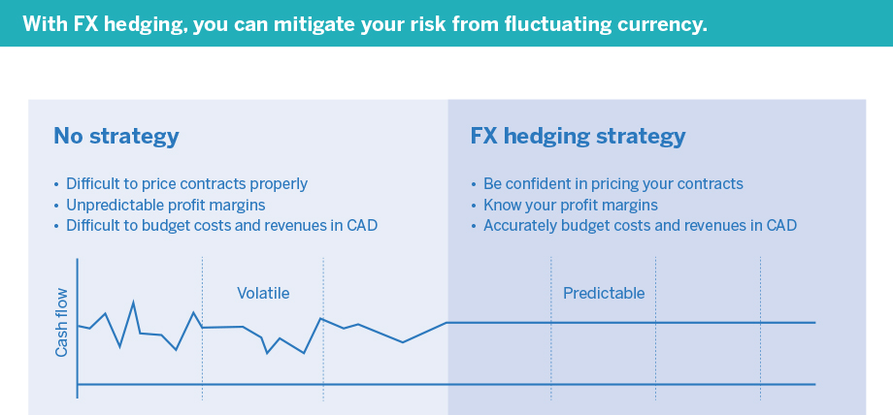

*SOURCE OF THE INFOGRAPHIC:* [*https://www.edc.ca/en/guide/fx-hedging-infographic.html*](https://www.edc.ca/en/guide/fx-hedging-infographic.html)

Genex can utilise a risk register as shown in Appendix ## to identify potential setbacks within the project and implement controls to mitigate them which allow more certainty in formulating revised project budget and also manage the expectations of stakeholders and investors.

Given the criticality of grid connection, Genex should prioritize early engagement with grid operators and regulatory authorities to streamline the process. It should conduct comprehensive feasibility studies to identify potential challenges and develop contingency plans to address unexpected delays or cost overruns. Allocating sufficient budget and resources to ensure timely completion of grid connection activities is equally important.

Risk Probability and Impact Assessment and Risk Data Quality Assessment allow for a systematic evaluation of potential risks based on their likelihood and impact which will enable stakeholders to analyse and begin the process of prioritising the risk (Hartley 2018, p.347). A risk matrix as shown in the table below can bed be constructed, incorporating the likelihood and impacts of risk events. The project risk register is the cornerstone document that *be reviewed and controlled constantly throughout the project.*

|  |  |  |  |  |  |
| --- | --- | --- | --- | --- | --- |
| **Risk Event** | **Probability** | **Impact** | **Priority** | **Strategy** | **Accountability** |
| Grid Connection Delays | 4 | Catastrophic (5) | 20 | Expedite negotiations and approvals with grid operators | Project Manager |
| Cost Overruns due to Currency Fluctuations | 3 | Major (4) | 12 | Implement financial hedging strategies | Financial Manager |
| Supply Chain Disruptions for Solar Panels | 3 | Major (4) | 12 | Develop alternative supplier relationships | Procurement Manager |
| Environmental Permit Delays | 2 | Moderate (3) | 6 | Engage early with regulatory bodies | Environmental Officer |
| Community Opposition | 2 | Moderate (3) | 6 | Strengthen community engagement plans | Community Liaison |

4.4 STAKEHOLDER MANAGEMENT

Managing stakeholder engagement by anticipating future problems, associated risks and reactions to different situations will reduce any conflict with stakeholders when unexpected issues arise [reference textbook]. With the Kidston Solar Farm being a renewable project, issues with integration were bound to occur at the end of the execution stage and the start of the finalisation stage. There are two ways Genex could implement this change. Firstly, they could account for future problems by including them in the stakeholder management matrix (see Table X as an example).

**Table X. Example of a Stakeholder Management Matrix to include anticipating future problems**.

|  |  |  |  |  |  |
| --- | --- | --- | --- | --- | --- |
| Stakeholder | Responsibilities | Information required | Format | Frequency | Who |
| UGL | Fixing connection issues to the grid | * Technical performance issues * Delays * Schedule delivery | Meeting | Weekly/Fortnightly until issue is resolved | Project Manager |

Secondly, Genex could have refined the contract scope for UGL. As mentioned in Part B, there was a contractual conflict after the connection to the grid was established. This means the contract scope was vague regarding connection issues. This should be clearly included or excluded in the contract scope with a monetary value assigned to the risk associated with the issue, so both parties are aware of the expectations.

These recommendations are made to improve stakeholder satisfaction and accountability. Stakeholder satisfaction is a key indicator of successful project management. With Genex looking to diversify their renewable energy portfolio, it is imperative they maintain good relationships with stakeholders moving forward.

4.5 COMMUNICATION MANAGEMENT

Regarding the communications throughout the planning stages, ways of improving such communications would be by conducting a kick-off meeting, which is the first meeting with the project team and stakeholders of the project, and by establishing a purpose and a common goal for the project. This helps solidify the purpose and outcome of the project (Atlassian, 2024). In addition, conducting continuous reporting on the project could help further strengthen the integrity of the project by assisting the management of the project status accurately and in real-time. For example, this is done by using a progress report, a status report, and a forecast report to ensure that the project is running smoothly. This can help the project team by being able to pinpoint and identify potential issues and errors of the project at each step of the project in both the planning and finalisation stages, as this creates a logbook of all the events that have occurred (PSA, 2024).   
  
Moreover, effective project control can be used in the finalisation stage of the project to ensure that the assets are performing to the standards required of them, such as monitoring and measuring the standards through regular inspections of these assets. As well as this, creating milestone charts and control charts can help construct a clear planning stage for the project, while documents such as contingency plans and change request register can be used to record and track all the changes in the project.

4.6 QUALITY MANAGEMENT

*Quality management in a solar farm project is paramount for ensuring efficiency, durability, and safety. “I found the largest risk is the connection risk, so that was a key learning for everyone throughout the process is to understand the connection risk and understanding the ground conditions. So those were the two things that brought a lot of the contractors unstuck. You would probably spend more attention on the grid studies grid connection studies.” Ben Guo said.*

*Ben Guo's insight emphasises the critical importance of understanding connection risks and ground conditions. To address these challenges effectively, additional recommendations for site assessment and grid connection commissioning are advised:*

*Thorough Site Assessment and Conducting a meticulous evaluation of the site before construction is essential. Engage geotechnical engineers to analyse soil samples, assess ground conditions, and understand local topography. This comprehensive assessment should identify potential risks like flooding or seismic activity, enabling the development of robust foundation designs tailored to site-specific conditions.*

*Grid Connection and Commissioning, During the final construction phase, prioritize the seamless integration of the solar farm with the external energy transmission grid. This involves connecting the central substation to the high-voltage grid, typically at 132KV or higher. (Queensland Government, 2018) Rigorous quality and safety checks must precede commissioning to ensure compliance with standards and regulations. Thorough testing and verification of connections, alongside adherence to safety protocols, are imperative to mitigate risks and ensure the reliability of the grid connection.*

*By implementing these two critical quality management measures, solar farm projects can effectively mitigate the risks associated with ground conditions and connection issues. This proactive approach contributes to the long-term success and optimal performance of the installation.*

**NEED 500 WORDS**

**CONCLUSION 26**

The Kidston Solar Project Phase 1 (KS1) by Genex Power, has demonstrated overall success, despite encountering key challenges during its lifecycle. The completion of the project, albeit with delays, signifies a significant milestone in the company's renewable energy portfolio.

Throughout the project, several key issues emerged that impacted its success. These included the lack of experience among contractors, leading to risks in expertise and execution, financial uncertainty due to substantial costs associated with grid connection, delays in project finance and commissioning affecting the timeline, challenges in stakeholder management and communication, and risks associated with international suppliers and foreign exchange financial risk.

To address the challenges faced and improve future project outcomes, it is crucial for Genex Power to focus on key areas of improvement. Several recommendations are proposed to avoid potential issues such as enhancing contractor selection processes to ensure expertise, conducting thorough feasibility studies for grid connection challenges, and prioritizing early engagement with regulatory authorities. Additionally, implementing robust stakeholder management strategies, improving communication practices, and strengthening quality control measures should be prioritized.

By investing in these critical aspects, Genex Power can enhance project success, mitigate risks effectively, and foster stakeholder satisfaction and accountability for sustainable project management. Learning from past challenges and leveraging these insights will enable Genex Power to navigate future projects with greater efficiency and success in the competitive renewable energy market.

**REFERENCES 27**

*ARENA Kidston Solar Project (Phase 1). (n.d.). Australian Renewable Energy Agency. https://arena.gov.au/projects/kidston-solar-project-phase-1/*

*ASX Announcement TWO EPC PROPOSALS SHORTLISTED FOR KIDSTON LARGE-SCALE SOLAR PV PROJECT*. (March 2016). https://announcements.asx.com.au/asxpdf/20160302/pdf/435jjl0cpb60gz.pdf

Crowley, A. (n.d.). *Prepared by Genex Power Limited*. https://genexpower.com.au/wp-content/uploads/2023/06/kidston-pumped-hydro-energy-storage-construction-report.pdf

*Kidston Solar Project (KS1)*. (n.d.). Genex Power. https://genexpower.com.au/50mw-kidston-solar-project/

Genex Power. (2021). Genex Power 2021 Annual Report (p. 15). Genex Power. https://www.listcorp.com/asx/gnx/genex-power-limited/news/annual-report-to-shareholders-2583900.html

Genex Power. (n.d.). 50MW Kidston Solar Project (KS1). Genex Power. https://genexpower.com.au/50mw-kidston-solar-project/

Power Technology. *Kidston solar project, Queensland, Australia*. (October 2021). Retrieved April 8, 2024, from https://www.power-technology.com/projects/kidston-solar-project-queensland/?cf-view&cf-closed

Queensland Government. (2018). Queensland Solar Farm Guidelines Practical guidance for communities, landowners and project proponents Department of Natural Resources, Mines and Energy. https://www.epw.qld.gov.au/__data/assets/pdf_file/0012/16122/solar-farm-guidelines-communities.pdf

ARENA. (n.d.). Kidston Solar Project (Phase 1). Australian Renewable Energy Agency. https://arena.gov.au/projects/kidston-solar-project-phase-1/

Genex Power. (2015). Development of up to 150MW Kidston Solar Project at Kidston “Energy Hub.” ASX Announcement. Australian Securities Exchange. https://cdn-api.markitdigital.com/apiman-gateway/ASX/asx-research/1.0/file/2995-01669949-2A883668

Guo, B. (2024, April 5). Kidston Solar Farm Phase 1 Project Interview [Microsoft Teams to Rachel Tausem, Ken Ji, Nicholas Duplex, & Ninu Latheesh].

Genex Power. (2016). GENEX FINALISES KIDSTON SOLAR PROJECT DELIVERY TEAM. https://cdn-api.markitdigital.com/apiman-gateway/ASX/asx-research/1.0/file/2995-01750692-2A956819

Genex Power. (2017). Knowledge Sharing -Submission II. https://genexpower.com.au/wp-content/uploads/2021/10/genex_power_knowledge_sharing_-_submission_ii.pdf

Genex Power. (2017). 50MW KIDSTON SOLAR PROJECT REACHES PRACTICAL COMPLETION. <https://cdn-api.markitdigital.com/apiman-gateway/ASX/asx-research/1.0/file/2995-02055600-2A1121405>

Genex Power. (2017). GENEX ACHIEVES FIRST ENERGISATION FOR KIDSTON SOLAR STAGE 1. <https://cdn-api.markitdigital.com/apiman-gateway/ASX/asx-research/1.0/file/2995-01925535-2A1051457>

Faiello, C. (2024). GENG5505: Project Management and Engineering Practice: Week 3b Lecture 6 14th March. [PowerPoint Slides]. <https://lms.uwa.edu.au/>

Faiello, C. (2024). GENG5505: Project Management and Engineering Practice: Week 1b Lecture 2 29th February. [PowerPoint Slides]. <https://lms.uwa.edu.au/>Atlassian. (2024). How to set up the perfect project kick off meeting. Atlassian. <https://www.atlassian.com/work-management/project-management/project-kickoff#:~:text=A%20project%20kick%2Doff%20meeting>

PSA. (2024). CrossConcept Continuum Project Management. Crossconcept. <https://www.continuumpsa.io/crossconcept-project-management#:~:text=Continuum%20enables%20your%20project%20team>

ASX. (2017, October 18). ASX Announcement: KIdston Solar Project (Phase one 50MW) Update. Genex Power ASX . <https://cdn-api.markitdigital.com/apiman-gateway/ASX/asx-research/1.0/file/2995-01909113-2A1043504>   
  
Power, G. (2016). Company Announcements Office Australian Securities Exchange Via: Electronic Lodgement GENEX FINALISES KIDSTON SOLAR PROJECT DELIVERY TEAM. <https://cdn-api.markitdigital.com/apiman-gateway/ASX/asx-research/1.0/file/2995-01750692-2A956819>

Powerlink. (2024). Genex Kidston Connection Project | Powerlink. Www.powerlink.com.au. <https://www.powerlink.com.au/projects/genex-kidston-connection-project>

Genex Power. (2016). Company Announcements Office Australian Securities Exchange Via: Electronic Lodgement GENEX FINALISES KIDSTON SOLAR PROJECT DELIVERY TEAM. <https://cdn-api.markitdigital.com/apiman-gateway/ASX/asx-research/1.0/file/2995-01750692-2A956819>Technology, P. (2021, October 4). Kidston solar project, Queensland, Australia. Power Technology. <https://www.power-technology.com/projects/kidston-solar-project-queensland/>

Hartley, S. (2018). Project management : a practical guide to planning and managing projects (Fourth edition.). Allen & Unwin.

‌

‌

**APPENDICES 29**

*Appendix #: Original and Revised Project Timeline Gantt Chart*

*Original Gantt Chart (NICK PLEASE)*

*Revised Gantt Chart (Genex Power, 2016)*

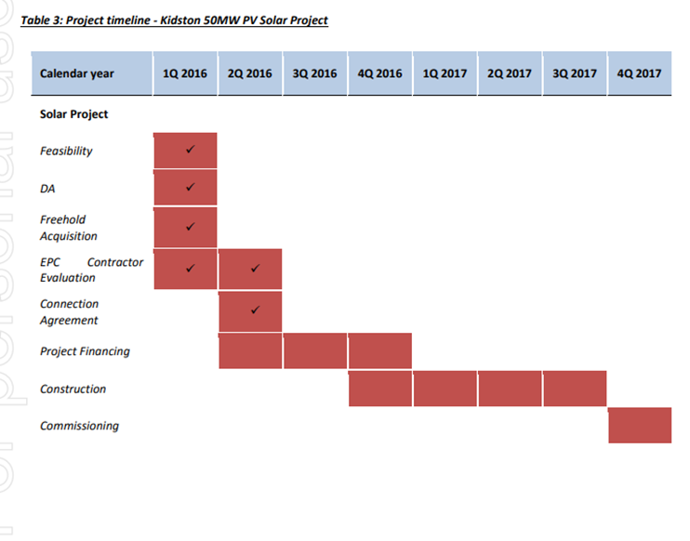

APPENDIX A: SCOPE OF SERVICES (EXTRACTED FROM THE DESIGN BRIEF AND PROPOSAL).

APPENDIX B: QUOTATION AND DETAILED BREAKDOWN PRICE SCHEDULE (EXTRACTED FROM THE PROPOSAL).

APPENDIX C: ORGANISATIONAL STRUCTURE (EXTRACTED FROM THE PROPOSAL).

APPENDIX D: RISK MANAGEMENT (EXTRACTED FROM THE PROPOSAL).

APPENDIX E: SCOPE VARIATION PROCEDURE (EXTRACTED FROM THE COMPLIED CONTRACT).

APPENDIX F: PROVISIONAL PROJECT SCHEDULE (EXTRACTED FROM THE PROPOSAL).

APPENDIX G: BASELINE GANTT CHART.

APPENDIX H: HAZARD ASSESSMENT (EXTRACTED FROM THE RISK REGISTER).

APPENDIX I: AN EXTRACTED COMPONENT OF THE CONSTRUCTABILITY REVIEW MINUTES.

APPENDIX J: ENGINEERING SUMMARY REPORT TABLE OF CONTENTS.

APPENDIX K: STAKEHOLDER CORRESPONDENCE (EXTRACTED FROM THE ENGINEERING SUMMARY REPORT).

APPENDIX L: CONSTRUCTIVE FEEDBACK FROM GHD AND WC (EXTRACTED FROM THE PROJECT KICK OFF MEETING MINUTES).

APPENDIX M: JOB VARIATION AND PROVISIONAL SUM ACTIVATION.

APPENDIX N: COST ESTIMATE (EXTRACTED FROM THE DESIGN BRIEF).

APPENDIX O: THE KEY PARAMETERS THAT CONTRIBUTED TO COST VARIATIONS (ADAPTED FROM GHD’S APPROVAL TO EXCEED PROJECT BUDGET).

APPENDIX P: THE RISK MANAGEMENT DILEMMA (HARTLEY 2018, P.379).

APPENDIX Q: OUTCOMES FROM BID CLARIFICATION MEETING (EXTRACTED FROM PROPOSAL).

APPENDIX R: STAGE 3 STAKEHOLDER MANAGEMENT ASSUMPTION (EXTRACTED FROM THE ENGINEERING SUMMARY REPORT).

APPENDIX S: UNRESOLVED ITEMS (EXTRACTED FROM THE ENGINEERING SUMMARY REPORT).

APPENDIX T: SEWAGE PUMP QUALITY MANAGEMENT SYSTEM (EXTRACTED FROM THE ENGINEERING SUMMARY REPORT).

APPENDIX U: NOTICE OF WATER CORPORATION AND GHD’S UPCOMING GEOTECHNICAL WORK.

APPENDIX V: PLANNED VALUE, EARNED VALUE AND ACTUAL COSTS (HARTLEY 2018, P.255).

APPENDIX W: POWER AND INTEREST MATRIX.

APPENDIX X: STAKEHOLDER MANAGEMENT MATRIX (HARTLEY 2018, P.160).

APPENDIX Y: RACI OR PARIS MATRICES (HARTLEY 2018, P.161).

APPENDIX Z: COMMUNICATIONS PROCESS MODEL (BELCH & BELCH 2004).

APPENDIX AA: PROJECT CONTROL DIAGRAM (HARTLEY 2018, P.353).

APPENDIX BB: QUALITY CONTROL PROCEDURES (HARTLEY 2018, P.276,277,278).

APPENDIX CC: GROUP CHURROS - AGENDA, MINUTES, GANTT CHART (ATTACHED)

|  |  |  |  |  |  |  |
| --- | --- | --- | --- | --- | --- | --- |
| ***Risk Description*** | ***Probability*** | ***Impact*** | ***Priority*** | ***Strategy*** | ***Accountability*** | ***Control*** |
| *Unforeseen adverse movements in foreign exchange rates* | *High* | *High* | *High* | *Implement advanced hedging mechanisms such as options and forwards to mitigate currency exchange rate risks.* | *Project Finance Team* | *Monitor currency exchange rates continuously* |
| *A shortfall in required capital due to currency fluctuations* | *Medium* | *High* | *Medium* | *Conduct a thorough review of the project's financial model and incorporate contingency plans for fluctuations.* | *Finance Department* | *Continuous monitoring of project financials* |
| *Perception of failure in project planning or risk management* | *Medium* | *High* | *Medium* | *Improve communication with stakeholders, providing transparent updates on the project's financial status.* | *Project Management* | *Regular stakeholder updates and progress reports* |
| *Dependence on a single currency or geographic region* | *Medium* | *Medium* | *Medium* | *Explore opportunities to diversify the supplier base to reduce dependence and minimize exposure to fluctuations.* | *Procurement Team* | *Diversification of suppliers and markets* |
| *Inadequate monitoring of currency exchange rates* | *High* | *Medium* | *High* | *Establish a robust monitoring and reporting system to track currency rates continuously and adjust strategies.* | *Project Finance Team* | *Implement automated tracking and reporting mechanisms* |
| *Lack of long-term strategic planning for market dynamics* | High | *High* | *Low* | *Develop a comprehensive long-term strategic plan that incorporates potential risks and uncertainties.* | *Project Management* | *Periodic review and update of strategic plan* |

MEETING MINUTES